**Exercise 18**

**Program 1**

Write a code in PL/SQL to develop a trigger that enforces referential integrity by preventing the deletion of a parent record if child records exist.

**PL/SQL Code:**

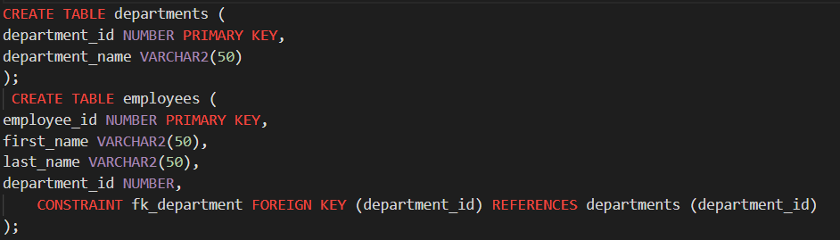

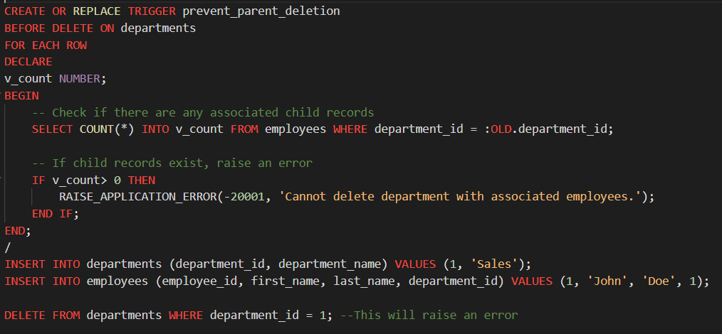

**Output:**

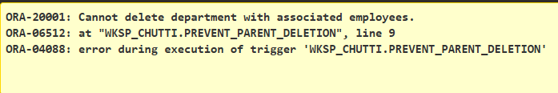

**Program 2**

Write a code in PL/SQL to create a trigger that checks for duplicate values in a specific column and raises an exception if found.

**PL/SQL Code:**

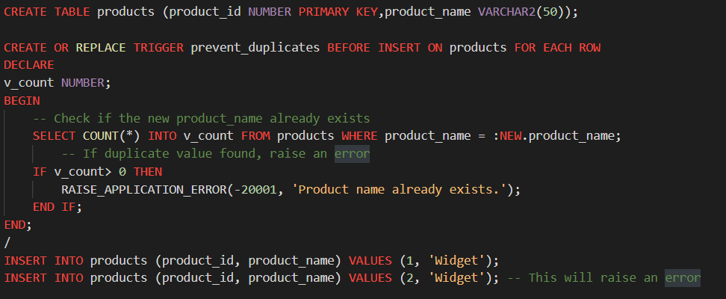

**Output:**

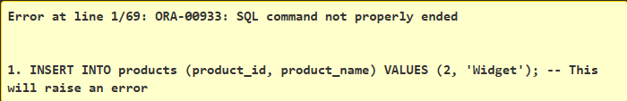

**Program 3**

Write a code in PL/SQL to create a trigger that restricts the insertion of new rows if the total of a column's values exceeds a certain threshold.

**PL/SQL Code:**

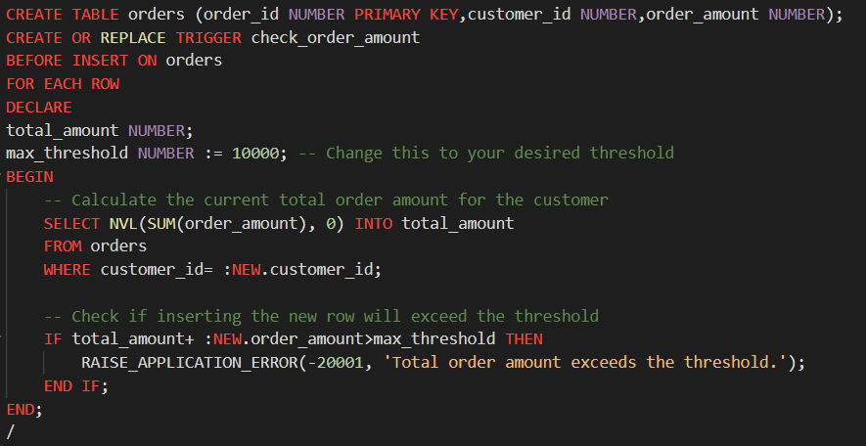

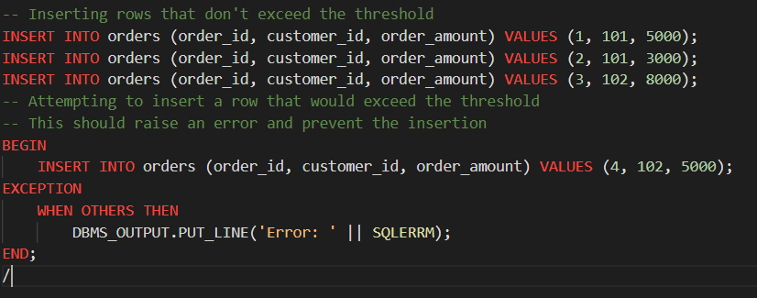

**Output:**

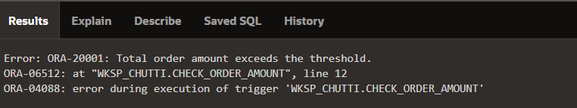

**Program 4**

Write a code in PL/SQL to design a trigger that captures changes made to specific columns and logs them in an audit table.

**PL/SQL Code:**

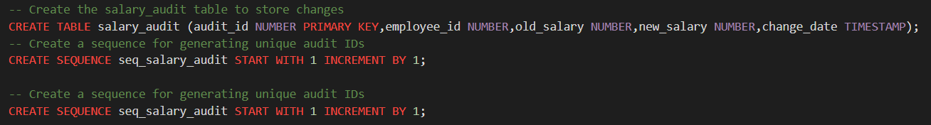

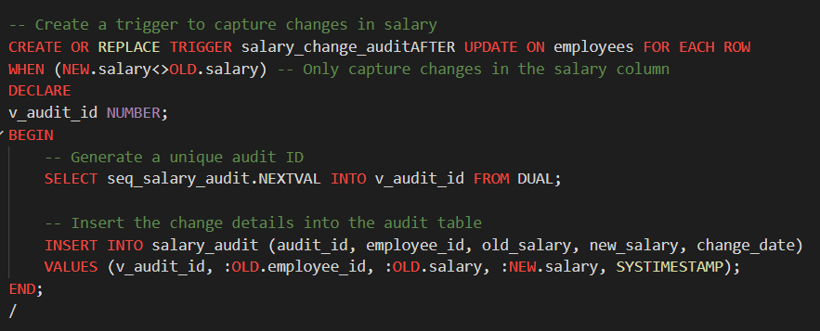

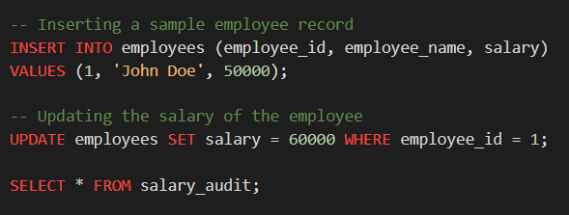

**Output:**

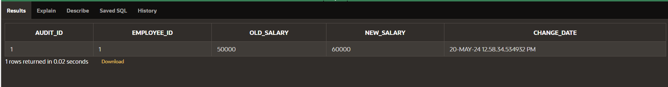

**Program 5**

Write a code in PL/SQL to implement a trigger that records user activity (inserts, updates, deletes) in an audit log for a given set of tables.

**PL/SQL Code:**

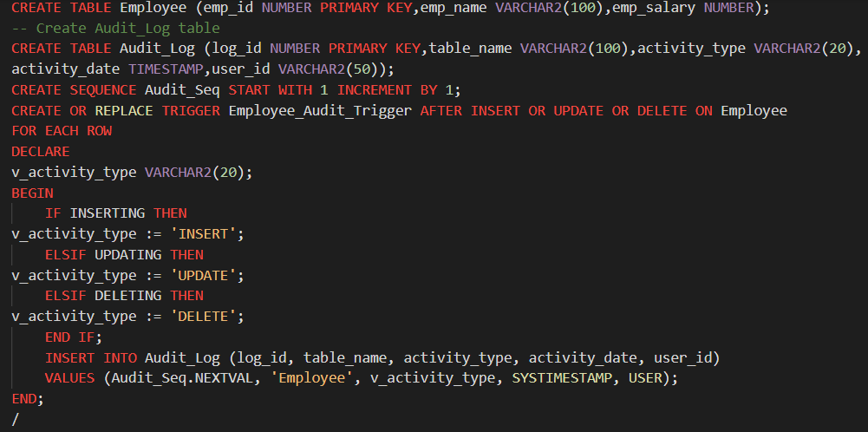

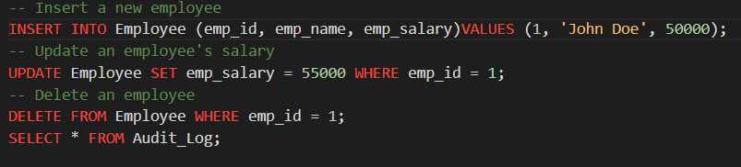

**Output:**

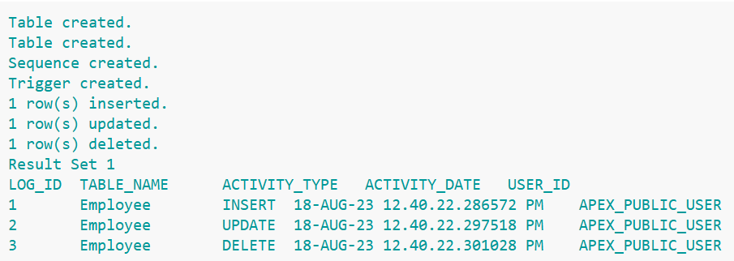

**Program 7**

Write a code in PL/SQL to implement a trigger that automatically calculates and updates a running total column for a table whenever new rows are inserted.

PL/SQL Code:

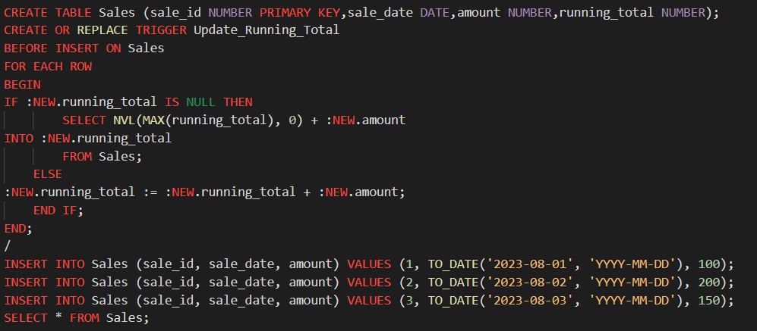

**Output:**

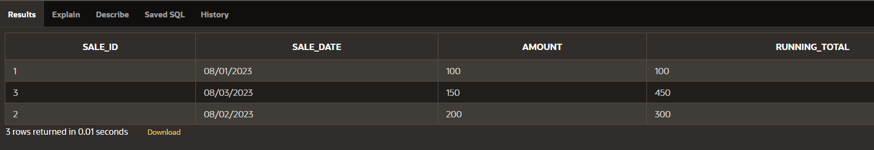

**Program 8**

Write a code in PL/SQL to create a trigger that validates the availability of items before allowing an order to be placed, considering stock levels and pending orders.

PL/SQL Code:

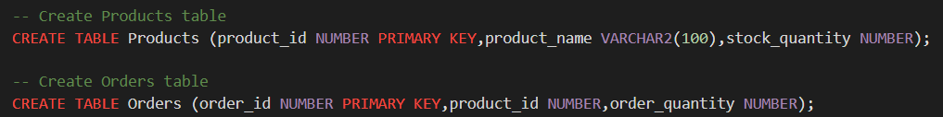

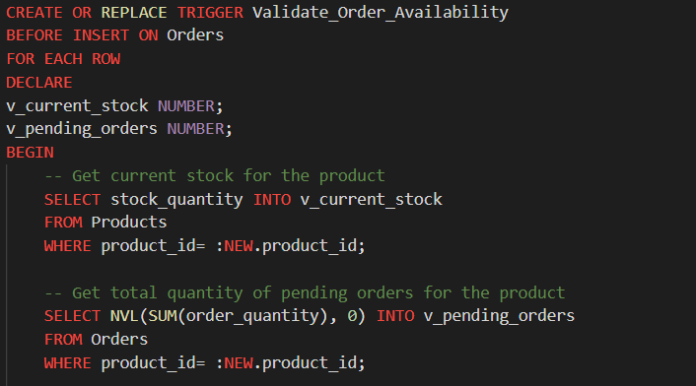

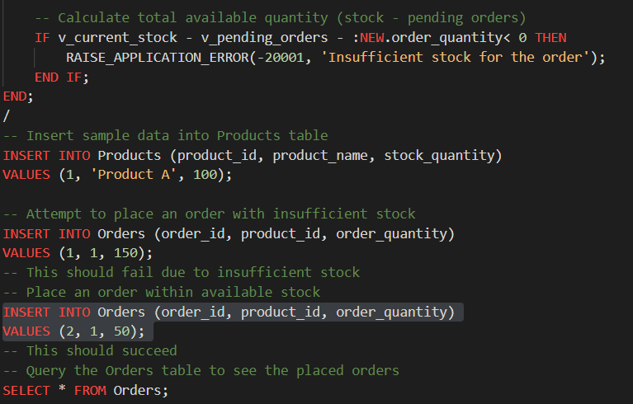

**Output:**

